GotSoccer
RefPay

Your Account
To Login go to www.gotsport.com as an Assignor. You will be presented with a home page that allows for selection of the assignor functions. The first step in preparing your account for the season will be to register as an assignor for our events.
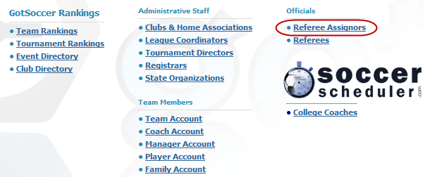
You will be presented with a new screen. If you are new to the MYSA Assignor system you will need to create a new account.
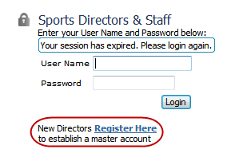
After login you will want to make sure your account is setup correctly. If you do not identify and create your account correctly referees will not be able to identify you.

Home Screen
When you login to www.gotsport.com as an Assignor. You will be presented with a home page that allows for selection of the assignor functions. This is the first step in accessing the RefPay system. You will want to select an Event to work with either from the drop-down or from that calendar.
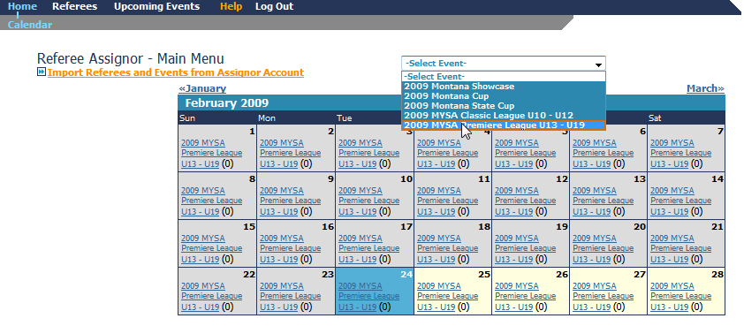The assignor functions will present themselves and you will want to select (Payment Report) from the list of tab choices.
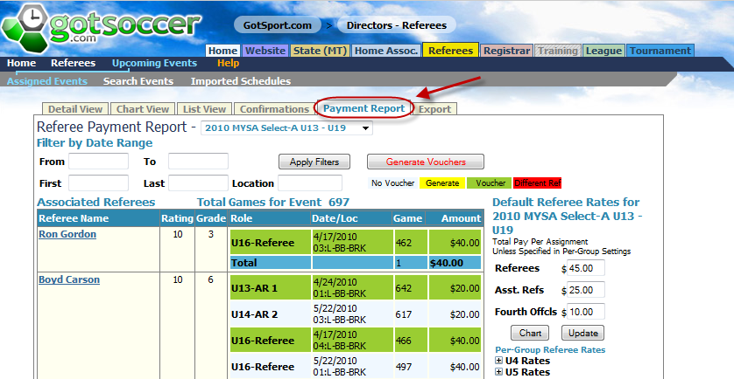
This page is used to select referee assignments for voucher generation. It is important to note that paying referees is a five step process.

- You select the games you wish to generate referee vouchers for using the filters on the (Payment Report) tab.
- Generate pay vouchers.
- From the Referees section make adjustments to the vouchers and update them.
- Select the vouchers to be paid and generate a batch.
- Download vouchers to export to an external system or print checks.
You are going to want to make sure that you have your pay rates correct. Please KEEP IN MIND that these rates are common across the entire event. If you make changes they affect every assignor using the system for this event. If you have special pay circumstances you may adjust the voucher amount in the pay voucher screen.
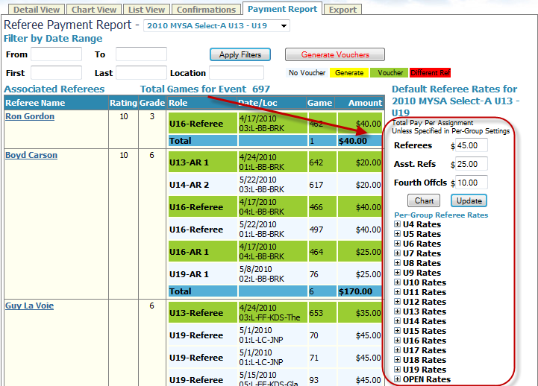
Once the data for the referee rates is correct you will see the results in the list view. Each referee is listed with a complete list of games based upon the filters set.

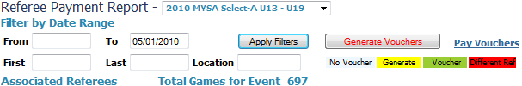
Filtering is allowed by:
- Event
- Date Range
- Referee (First, Last Name)
- Name of the location of the game
Using these allows the assignor to narrow the voucher generation to just the items needed. The four colors used provide a visual queue as to the payment status of the game for this referee.
- Light Blue/White – There are no vouchers for this referee/game at this time.
- Yellow – A voucher was just generated.
- Green – A voucher has been generated and is in the pay system for the referee/game.
- Red – A voucher has been generated for this game and position but a different referee was assigned to that position at the time the voucher was generated.
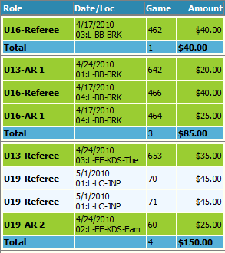
The list supplied gives the assignor a detailed view into the event. Each column provides information about the match.
- Role – Match age and referee position for the match
- Date/Loc – Date of the match followed by the field ID and the name of the location of the match. This data is truncated so only the first few characters are shown for the location.
- Game number of the event
- Amount owed to the referee based upon the table for the event. Note : If the amount is wrong then the table is setup incorrectly. Please adjust there.
Once all of the information selected is correct the assignor my generate a pay voucher for each match by clicking . This will refresh the display once completed and all newly generated voucher games will be highlighted in yellow.
To pay these vouchers click on the Pay Vouchers link and the screen will be refreshed with all of your to-be-paid vouchers displaying.

Paying Vouchers
After selecting Pay Vouchers from the payment report screen the assignor will be presented with the pay voucher list.
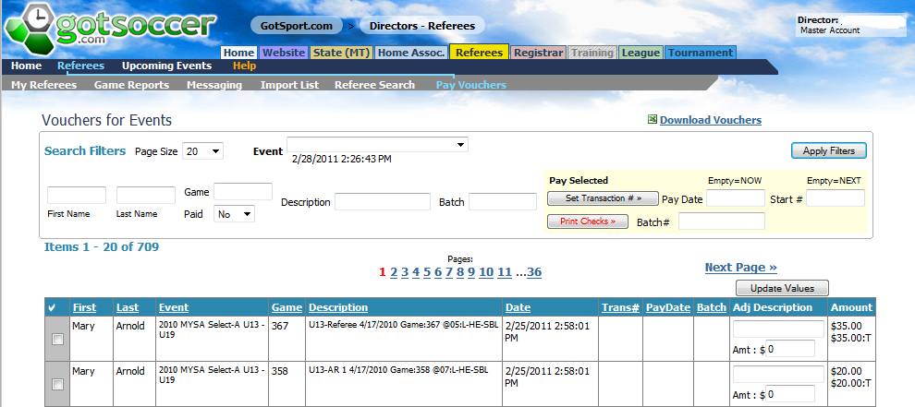
As always the GotSoccer system offers a wealth of search opportunities so that the assignor may fine-tune the list to exactly what needs to be viewed.
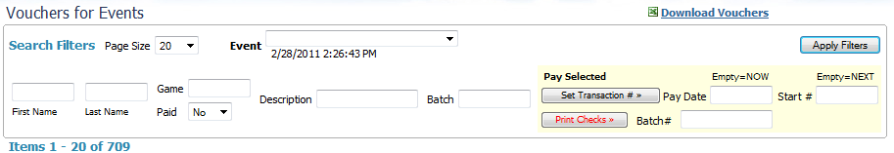
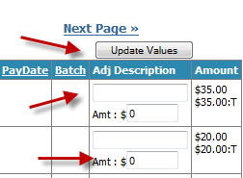
Once the list has been filtered appropriately adjustments should be entered. The system provides for both an adjustment description and an amount. The amount field may be positive numbers for additional pay or negative numbers to allow for deductions or fines. Once complete with all of the adjustments on this page click the Update Values button at the top of the column. Remember that you may have multiple pages of adjustments to complete. Use the same process for the contents of each of the pages.

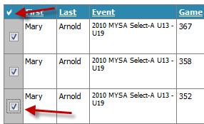
Next the vouchers to be paid must be selected. This is accomplished by clicking the checkbox at the top of the column to select the entire list or by individually selecting each line item. When you are satisfied with the selections proceed to the top of the list area and in the yellow box prepare the selected items for payment.
Note : Once the Transaction number has been posted the line/game may not be edited again.
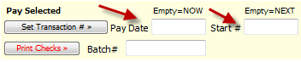
PRIOR to clicking set transaction number you may want to enter a check/transaction payment date and a starting check/transaction number. If the 2 fields are left blank they will be automatically filled in with the current date and the next available number respectively.
Click the Set Transaction # button. A pop-up window will appear asking for validation. You may cancel or accept at this point.
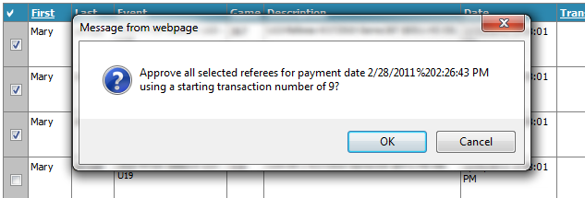
The newly generated vouchers are now ready to be printed or downloaded for external payment systems.

To select vouchers for download or payment you will want to filter for paid vouchers and a specific batch ID.
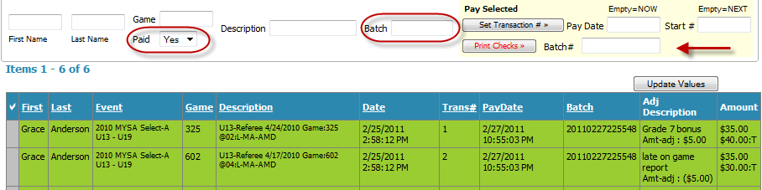
Click Apply Filters the list presented will show the batch to be printed or downloaded. To print checks type in the batch number (extra precaution) and click Print Checks. To download to Excel there are not special steps just click Download Vouchers at the top of the filter box.
The check type used is. Item 881013 from Deluxe Forms http://www.deluxeforms.com
